14) Write a C program to implement the Tree Traversals (Inorder, Preorder, Postorder)

PROGRAM:

#include <stdio.h>

#include <stdlib.h>

struct Node {

int data;

struct Node\* left;

struct Node\* right;

};

struct Node\* createNode(int data) {

struct Node\* newNode = (struct Node\*)malloc(sizeof(struct Node));

newNode->data = data;

newNode->left = NULL;

newNode->right = NULL;

return newNode;

}

void inOrder(struct Node\* root) {

if (root == NULL) return;

inOrder(root->left);

printf("%d ", root->data);

inOrder(root->right);

}

void preOrder(struct Node\* root) {

if (root == NULL) return;

printf("%d ", root->data);

preOrder(root->left);

preOrder(root->right);

}

void postOrder(struct Node\* root) {

if (root == NULL) return;

postOrder(root->left);

postOrder(root->right);

printf("%d ", root->data);

}

int main() {

struct Node\* root = createNode(1);

root->left = createNode(2);

root->right = createNode(3);

root->left->left = createNode(4);

root->left->right = createNode(5;

printf("Inorder traversal: ");

inOrder(root);

printf("\n");

printf("Preorder traversal: ");

preOrder(root);

printf("\n");

printf("Postorder traversal: ");

postOrder(root);

printf("\n");

return 0;

}

INPUT:

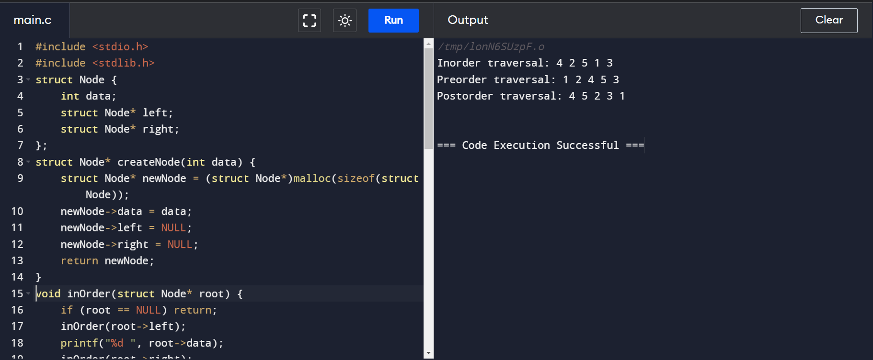

OUTPUT:

